**Orientation Information**

1. **Registration Processes and Getting Started**
   1. **KCGI Email address, Username and Password**

In the orientation day, you will receive the document including above details.

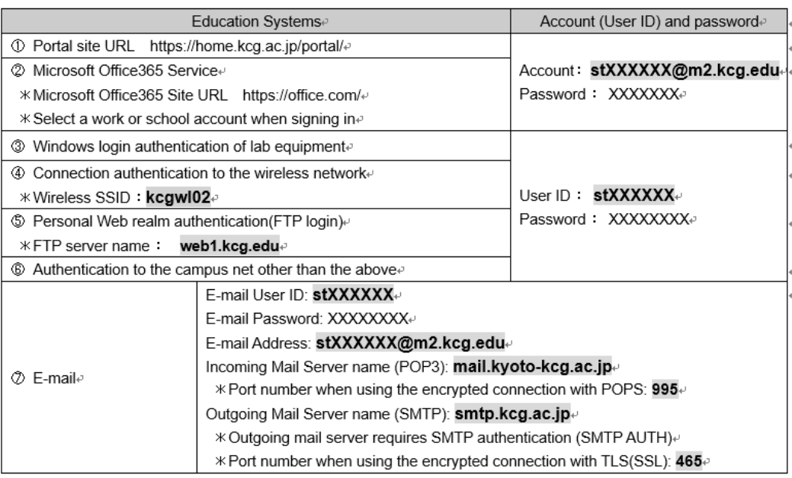

*Source : KCGI portal system*

* 1. **Familiarity with the KCGI Website**
     1. Accessing the KCGI website

There are three websites which are used during our academic life. To access those websites you have to keep in mind your user name and password.

* + - * **[Portal](https://home.kcg.ac.jp/portal/)**

<https://home.kcg.ac.jp/portal/>

All the announcements from KCGI are displayed in this portal. And also, you can find the user manuals and more information from this web site.

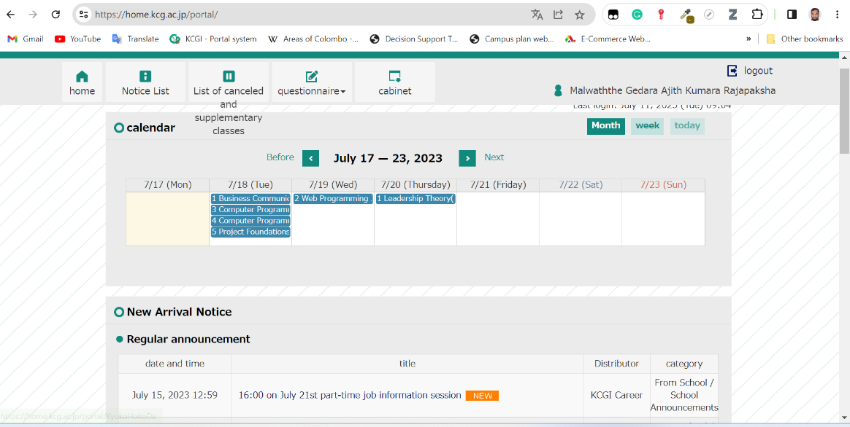

You can also navigate to other web sites from this portal.

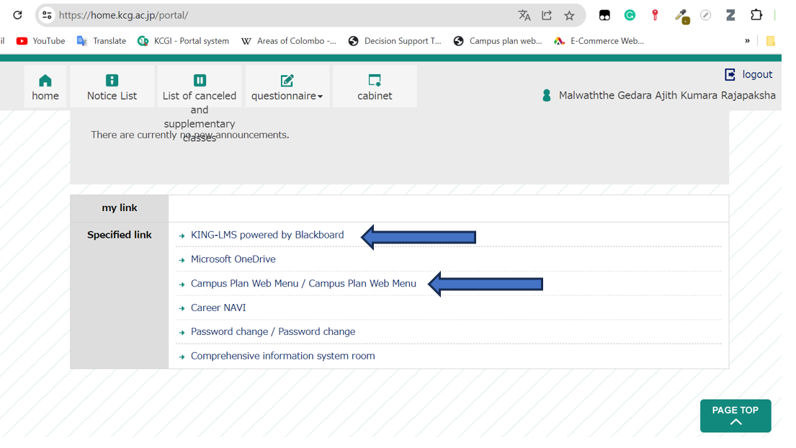

* + - * Campus Plan Web Menu

<https://king-lms.kcg.edu/>

All the course materials, activities, quizzes and assignments are uploaded to this LMS.

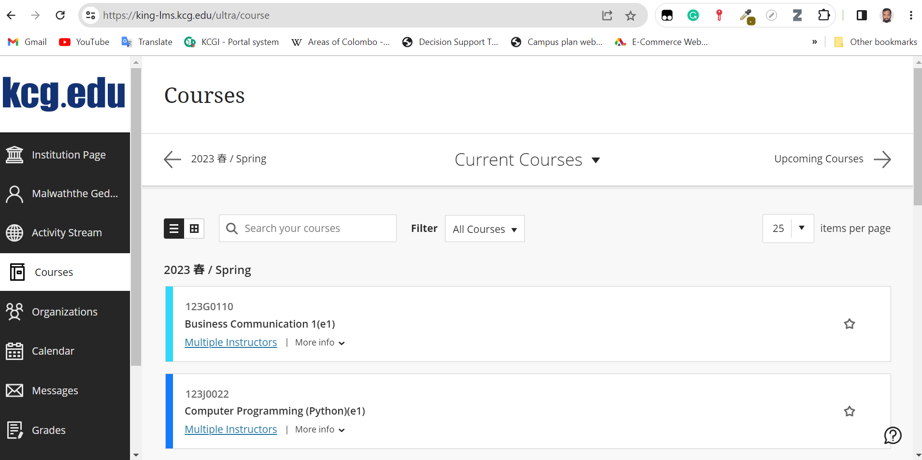

* + - * King LMS

<https://home.kcg.ac.jp/gakusei/web/CplanMenuWeb/UI/MainMenuV2.aspx>

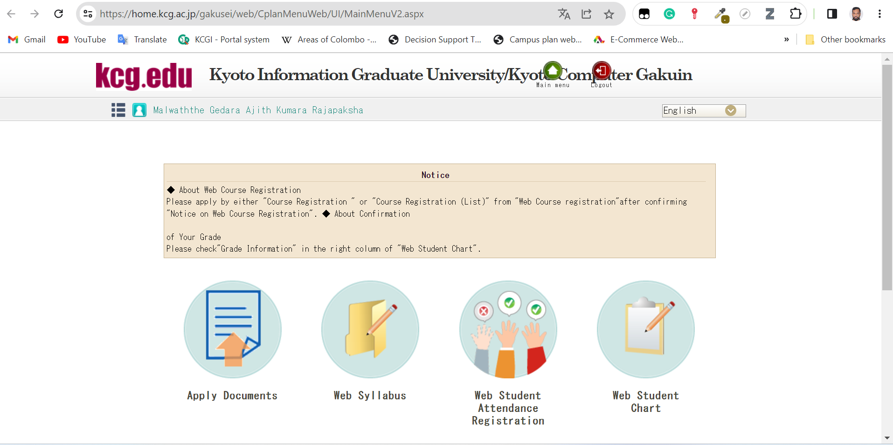

* + 1. Navigating the different sections of the website
* Portal

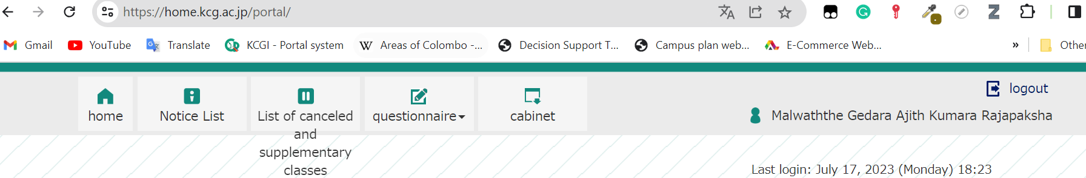

* + **Home**

Includes Timetable, Regular Announcement and Important Links.

* + **Notice List**

Includes List of Announcements. Here you can filter the announcement based on the specified categories.

* + [**List of canceled and supplementary classes**](https://home.kcg.ac.jp/portal/KyukoHokoEtc)
  + **Questionnaire**
  + **Cabinet**

In this section all the information related to the students are uploaded.

* Campus Plan Web Menu

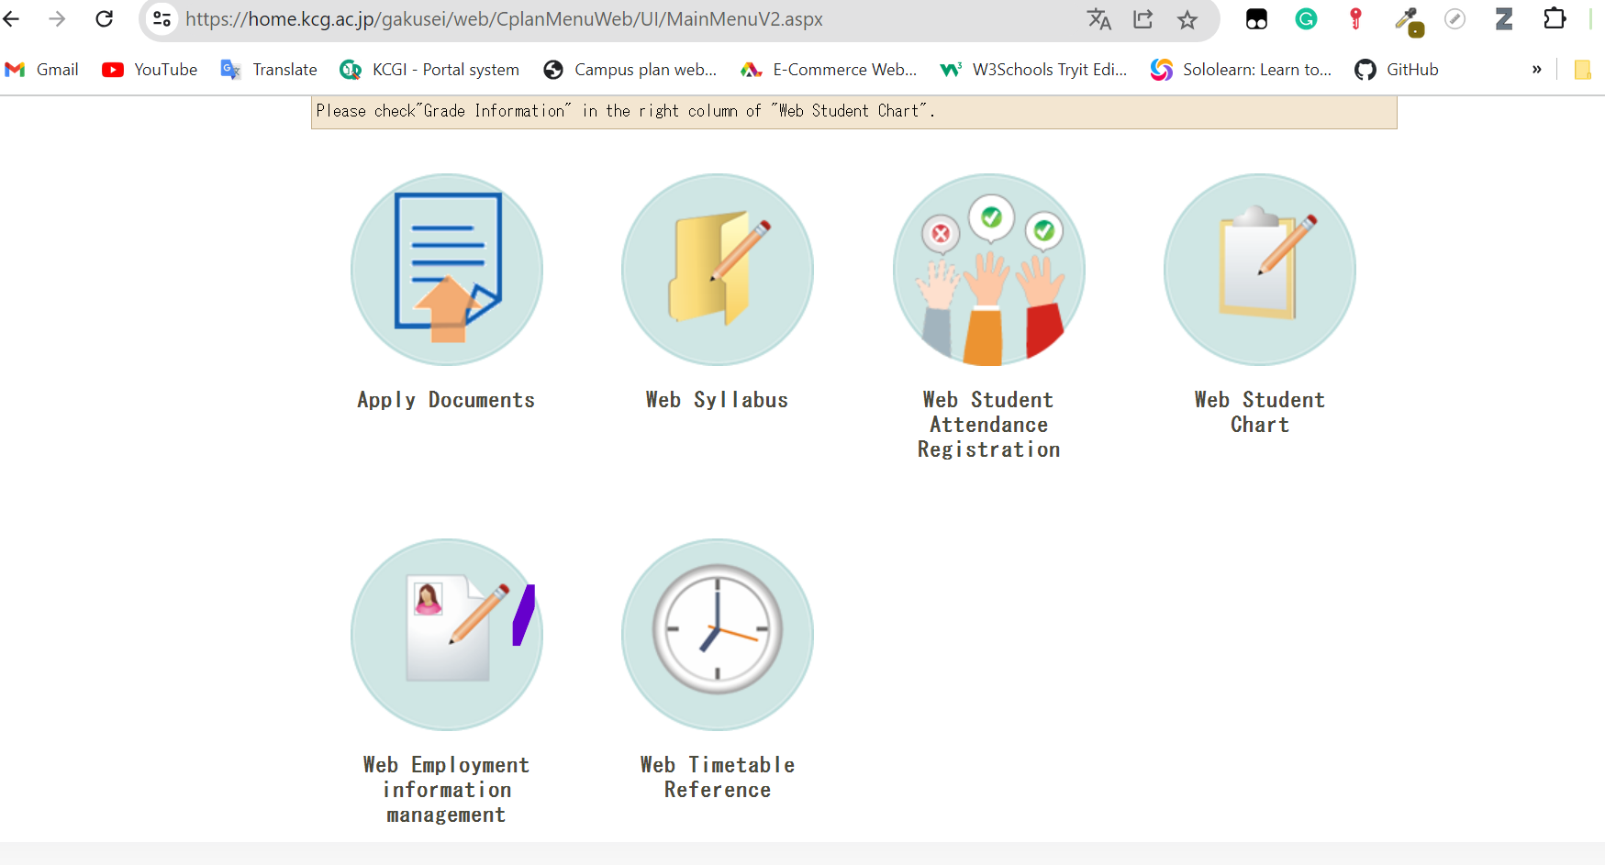

* King LMS

Here all the details related to your courses will be uploaded. Such as study materials, assignments, Quizzes, announcement related to the courses and also you can find your grade for the courses.

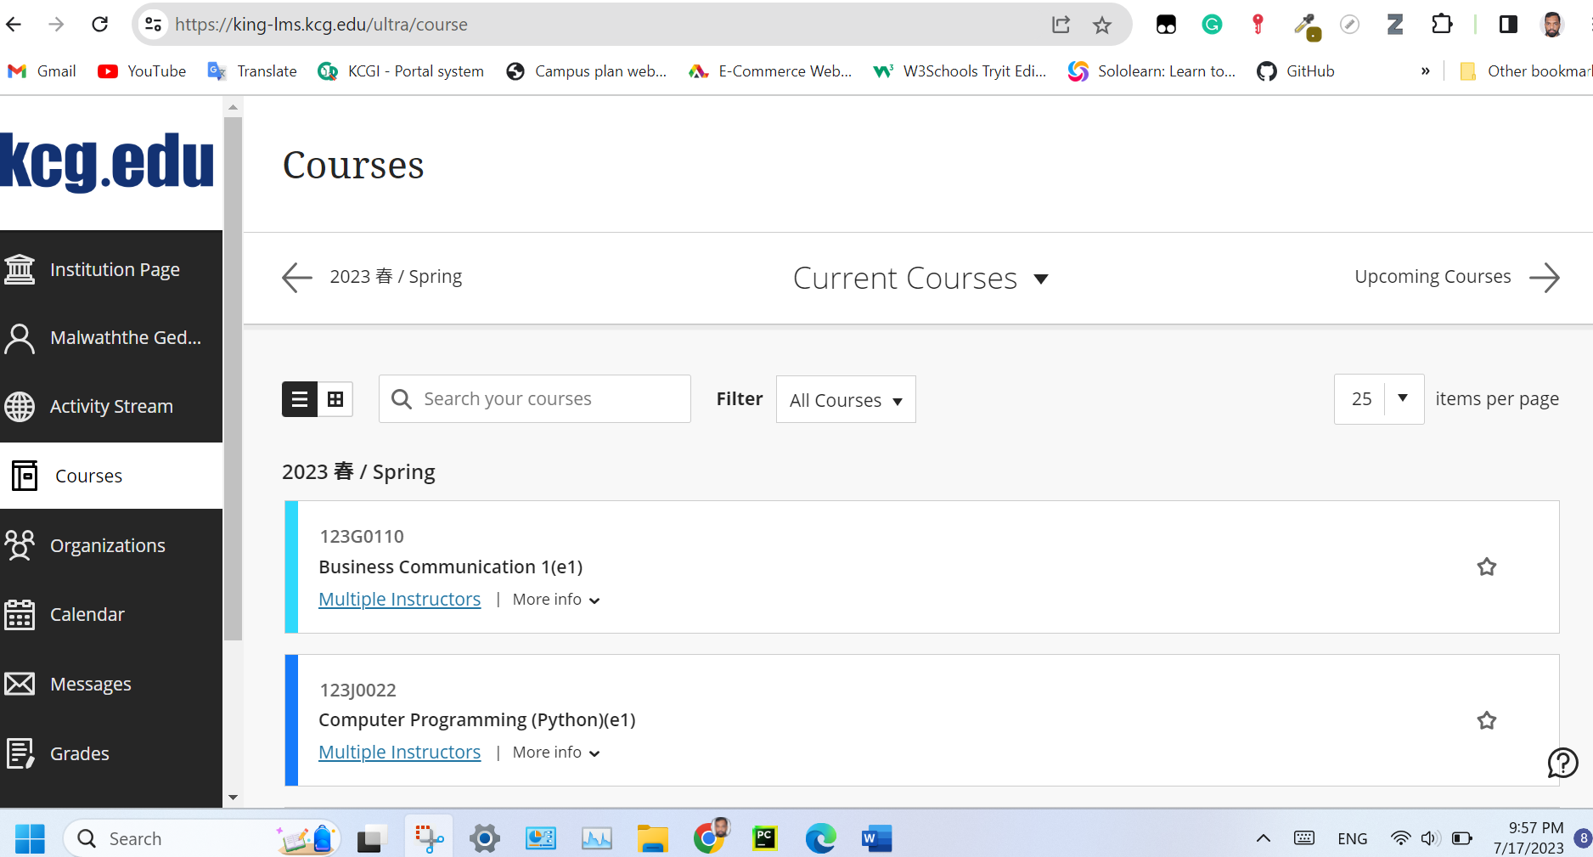

* 1. **E-mail Setup (Linking College Email to Outlook)**
     1. Accessing the email account through Outlook

Please follow the instructions given below

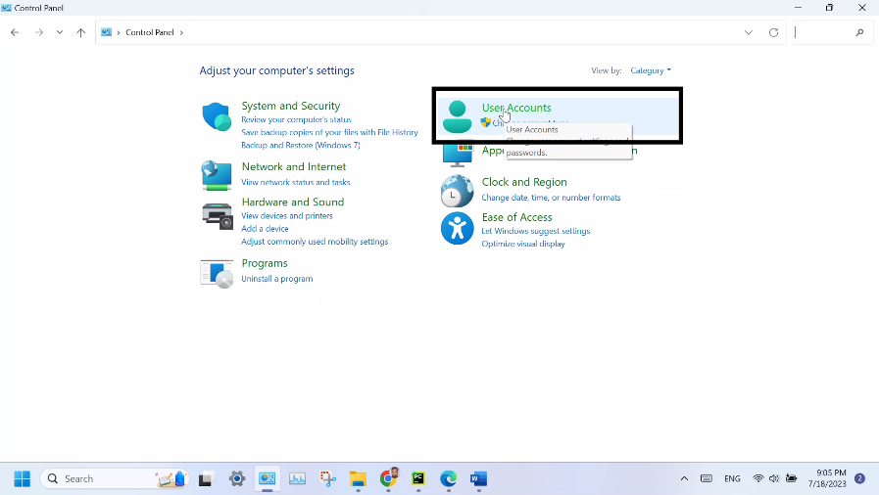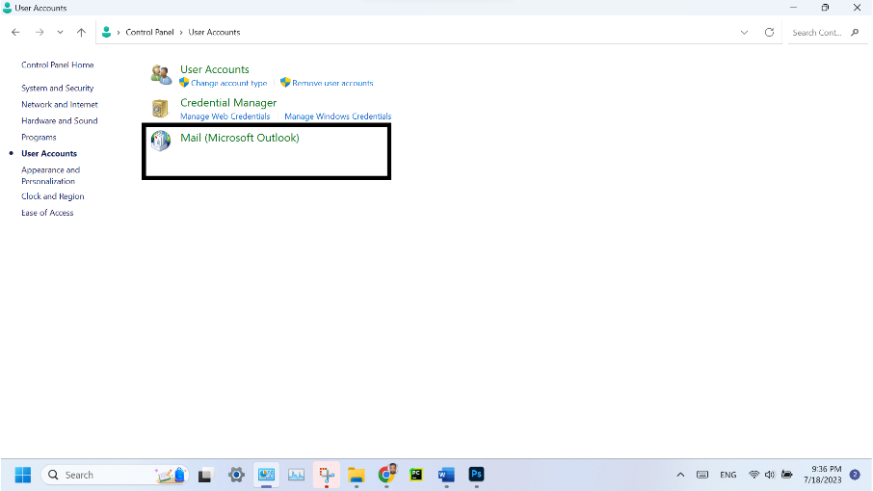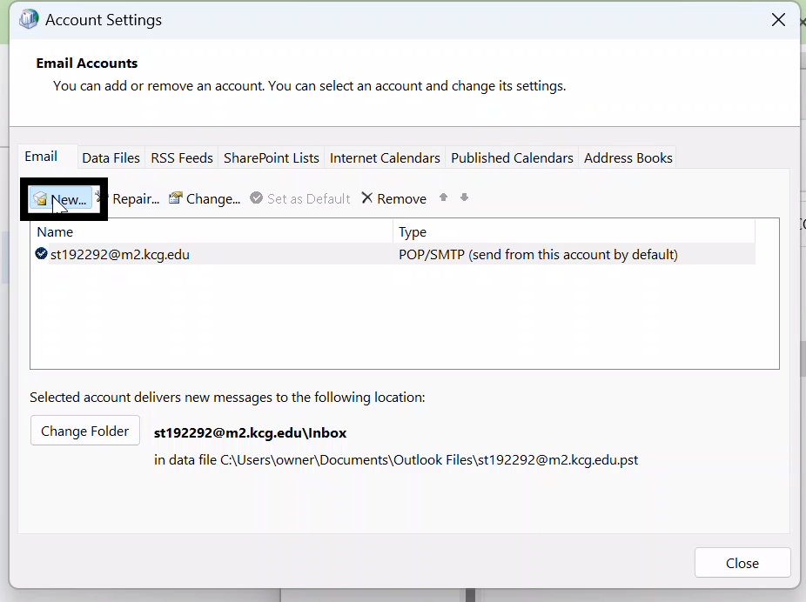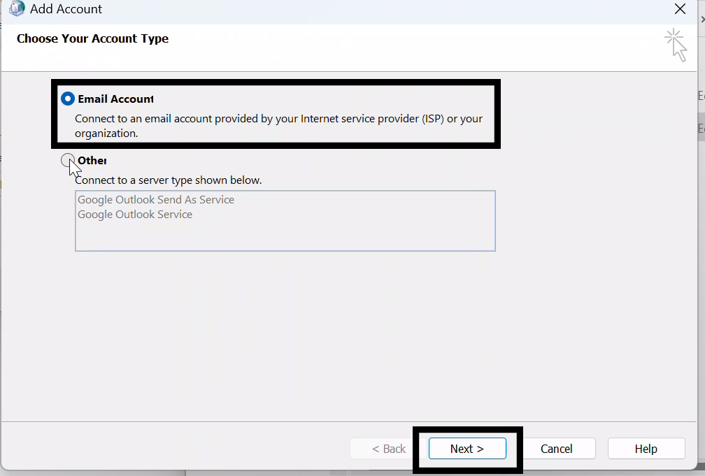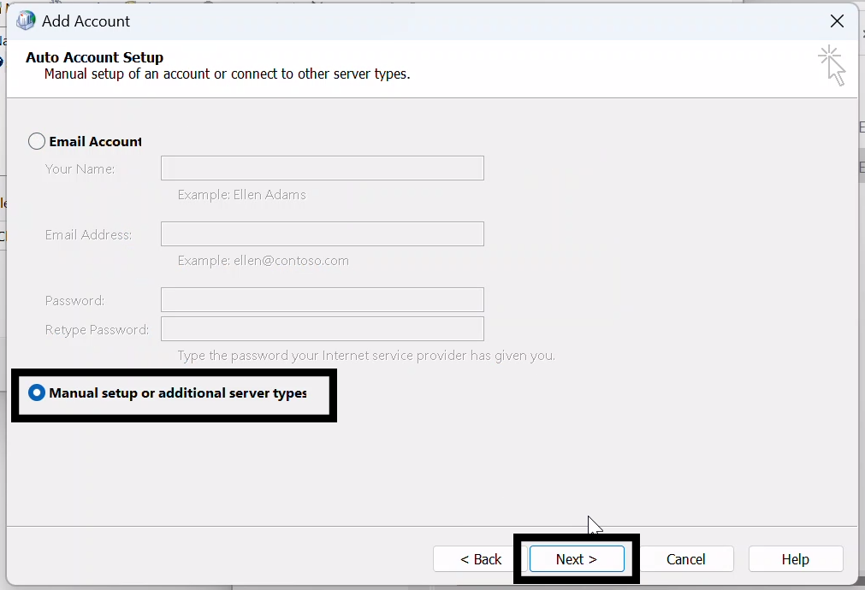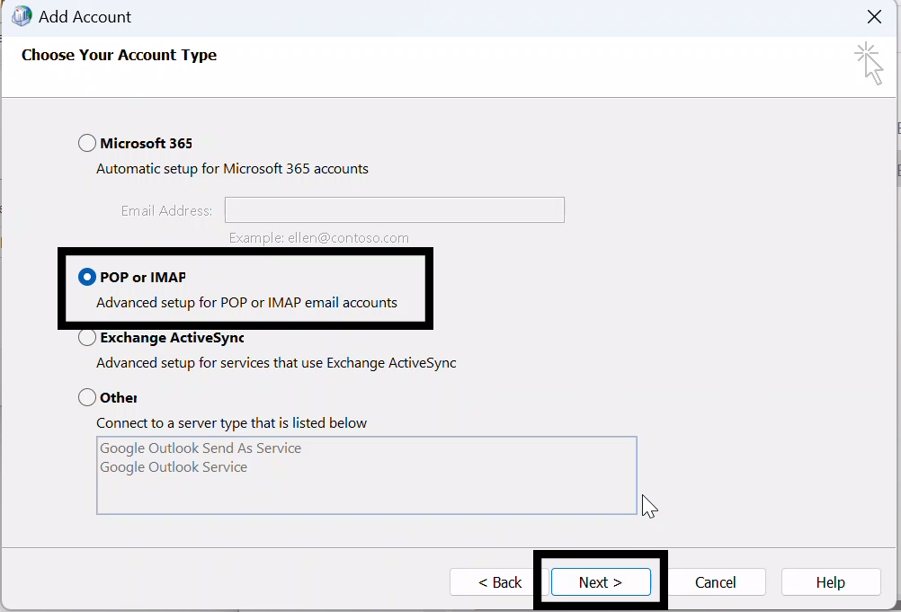

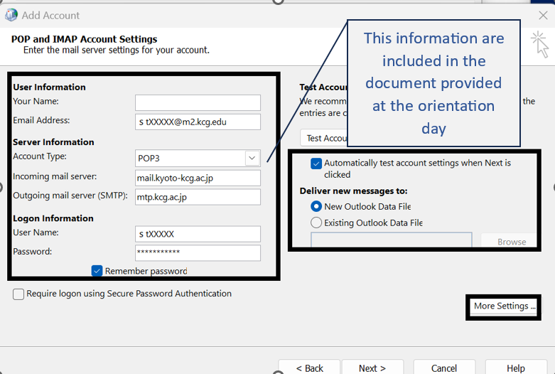

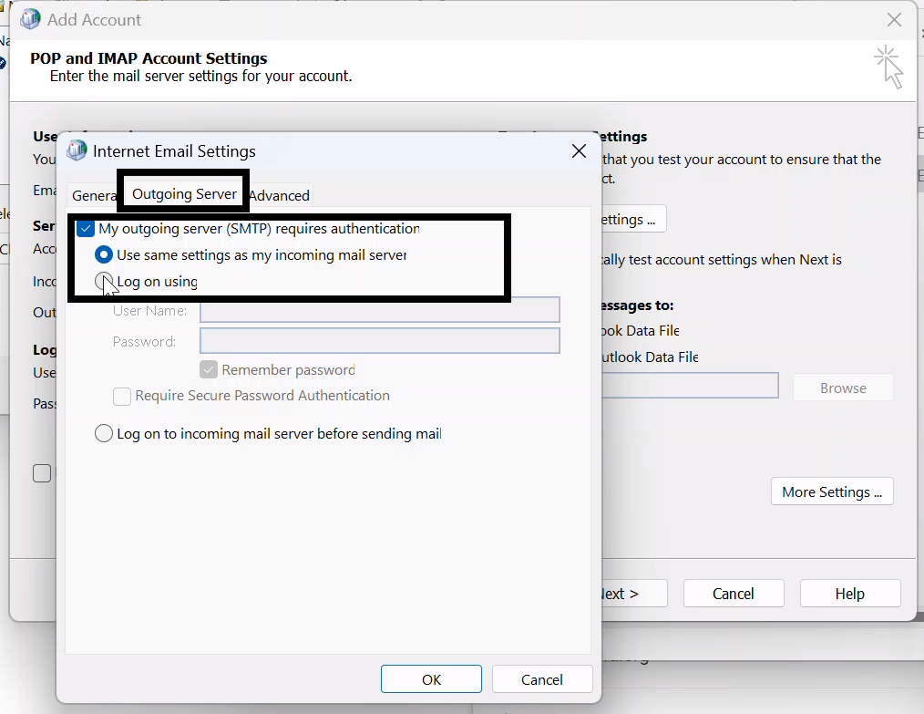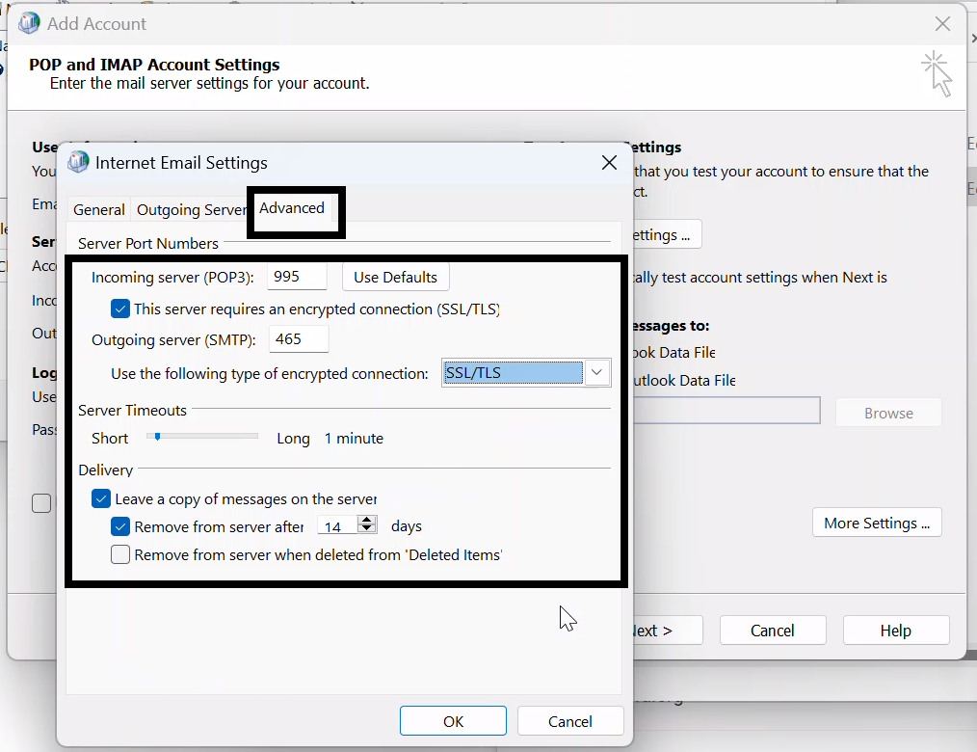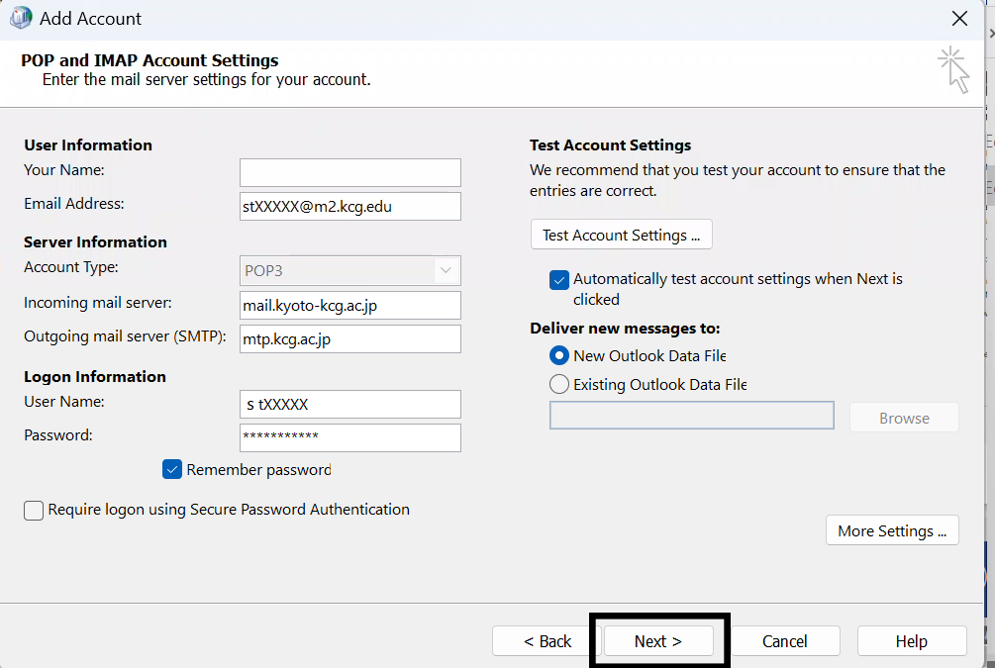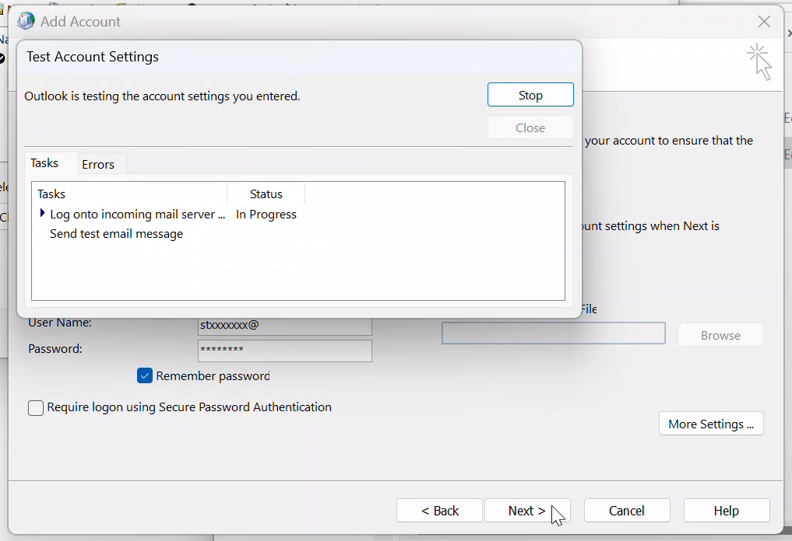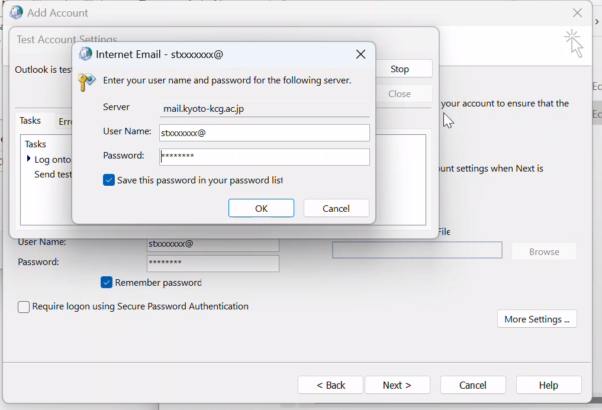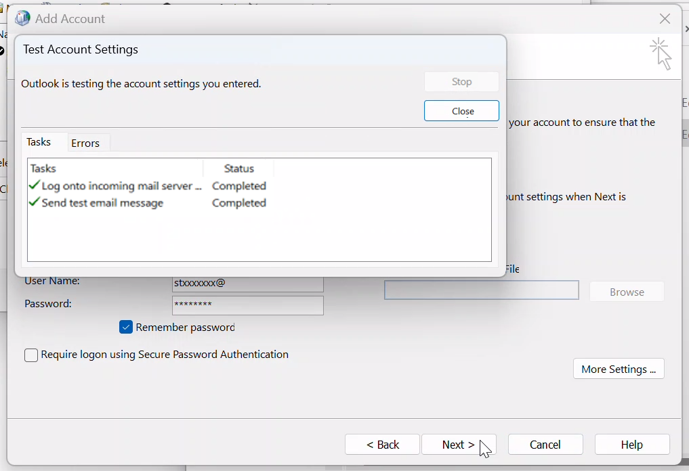

* 1. **Notifying Address Changes**
     1. Procedures for notifying changes of address or contact details.
* First of all, you have to log in to the **campus plan web menu.**
* Then you can go to Apply Document

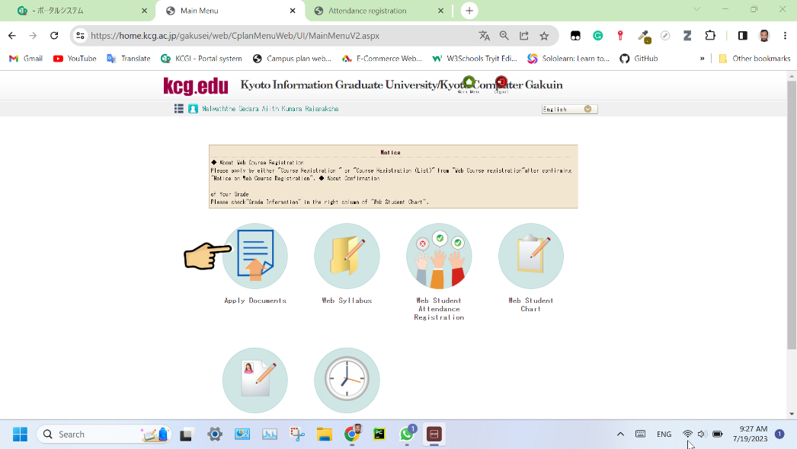

* Next click the application screen

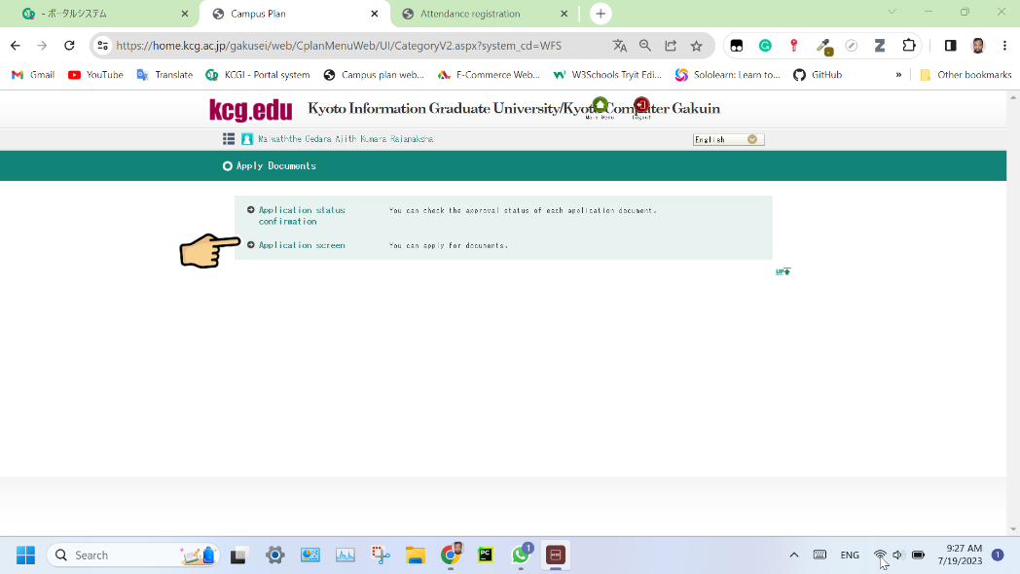

* Select the Change of Address Notification

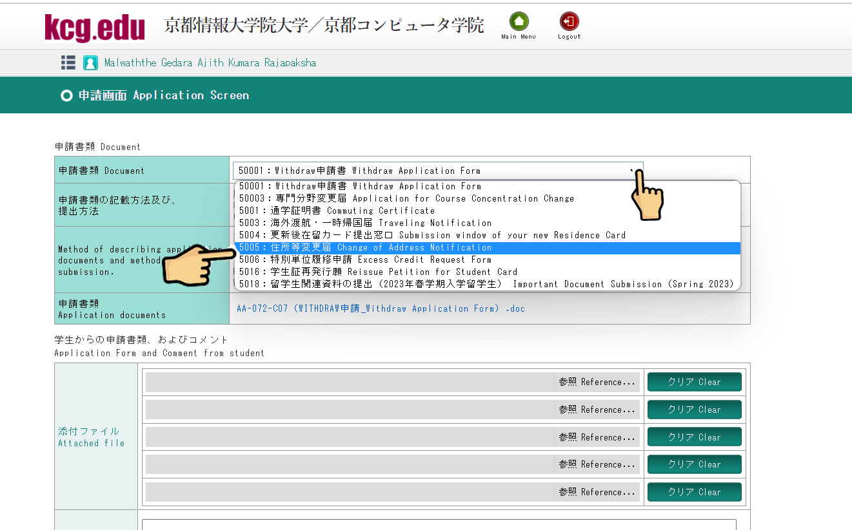

* Then it will appear the required documents and you can download them.

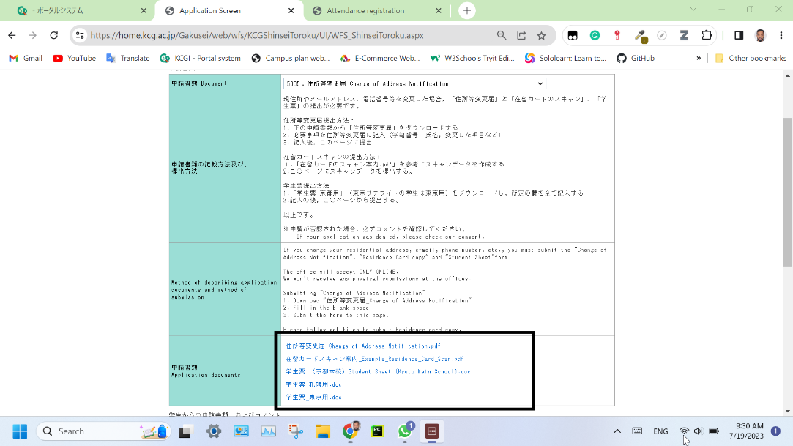

* Then you upload the completed documents and click the Apply button

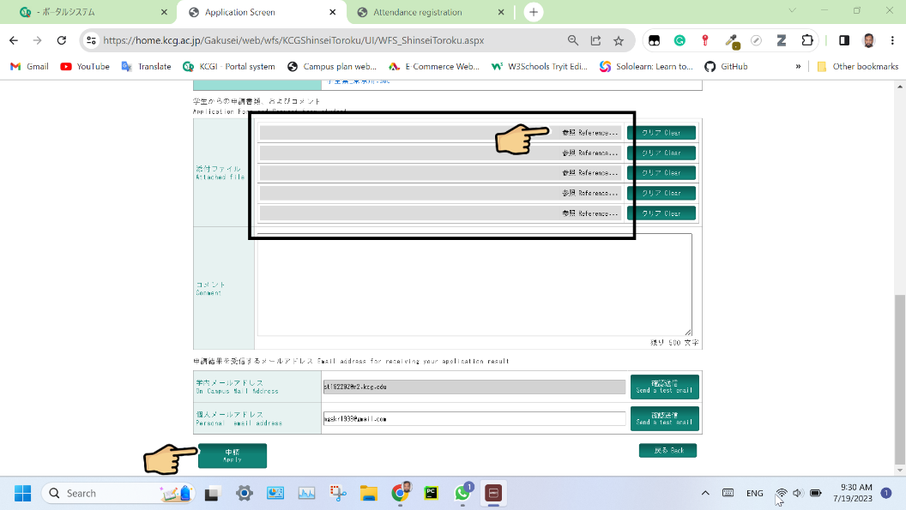

* + 1. Consequences of not updating address information

If you don’t update your address, then the old address will be displayed on the documents issued by the university.

* 1. **Courses and Timetable Check**
     1. Accessing the course pathway
     2. Find the scheduled courses for particular semester

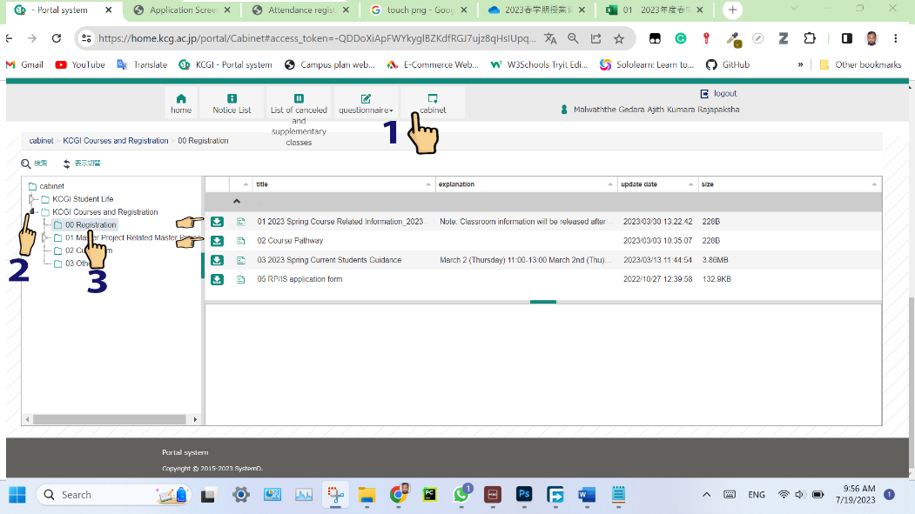

* 1. **Copying Residence Card**

You can scan your Residence Card at any convenient store. The following is an example of Lawson store.

* First of all, you have to touch the any place on the screen or touch the exit button of the photocopy machine.

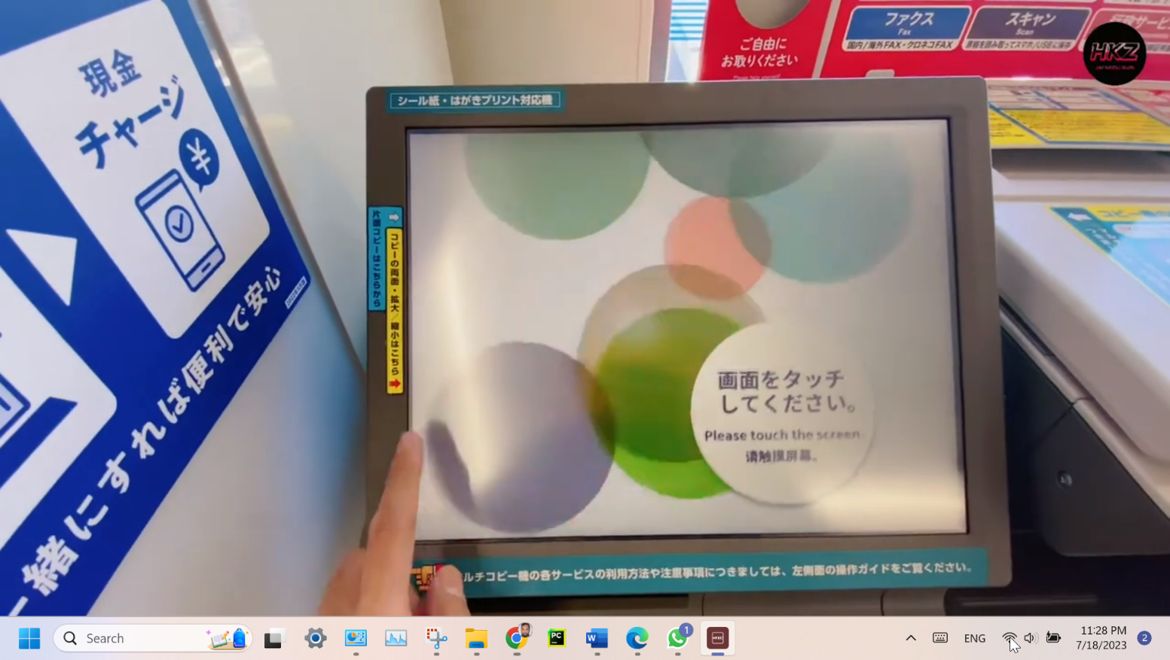

* Then it will appear in the main window, and you can select the language.

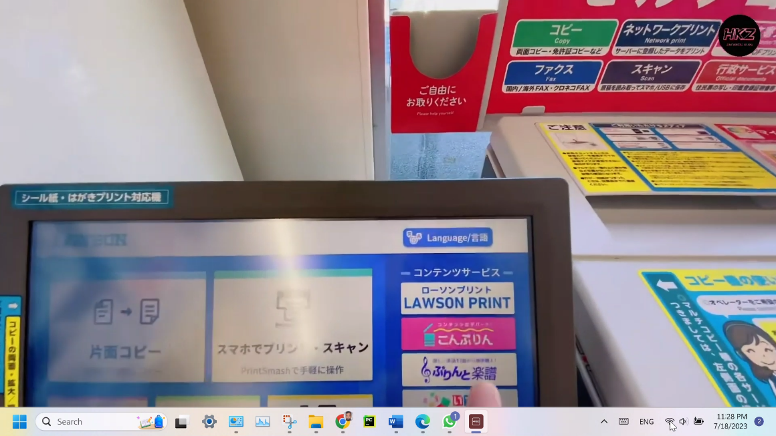

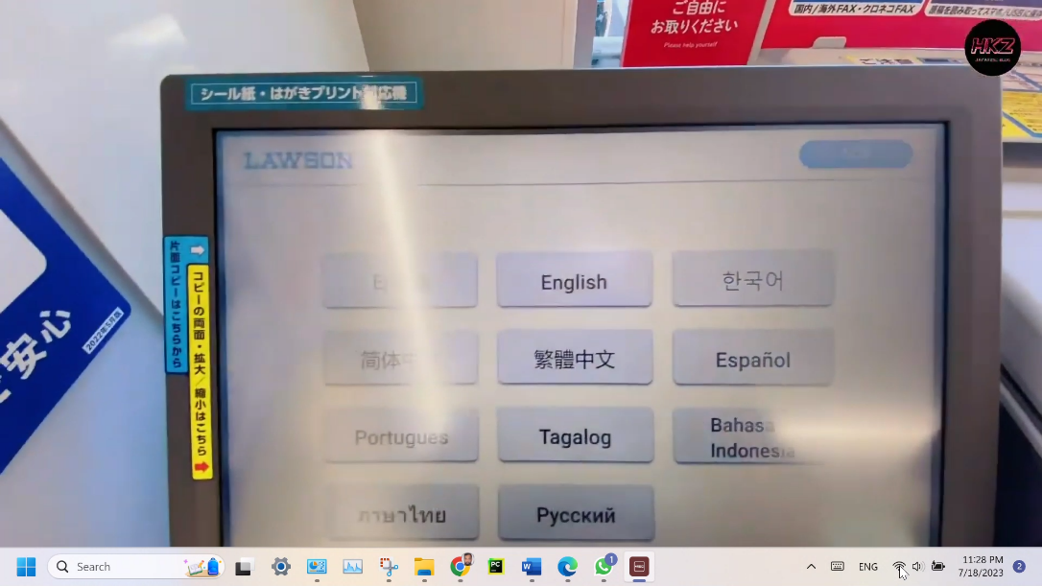

* Next you have to click the various copy.

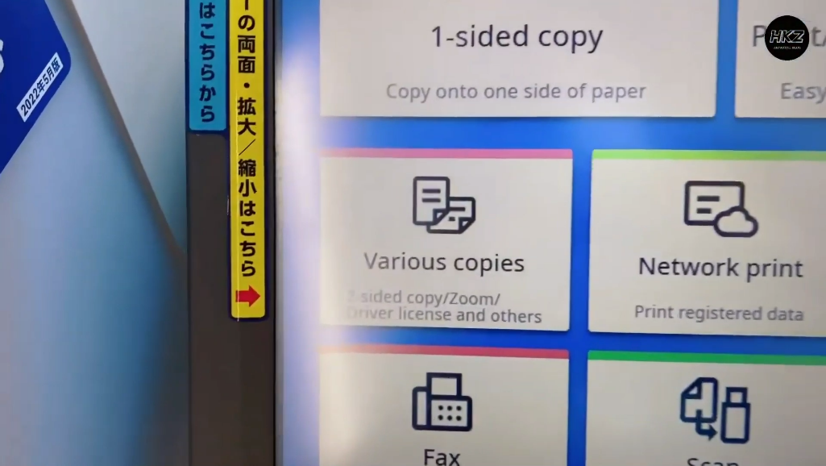

* Then select the Driver license/Card.

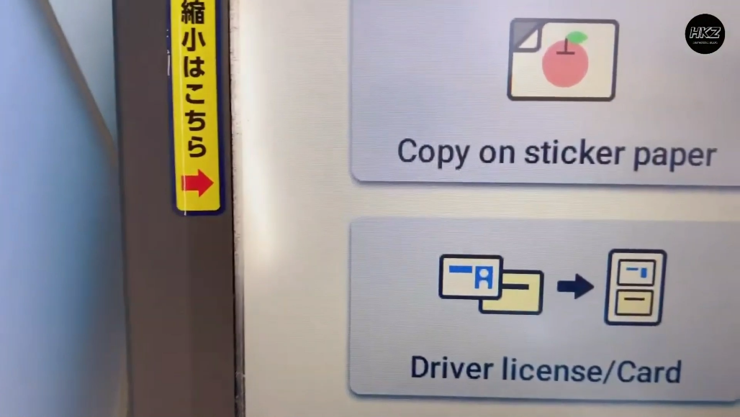

* Select the color mode

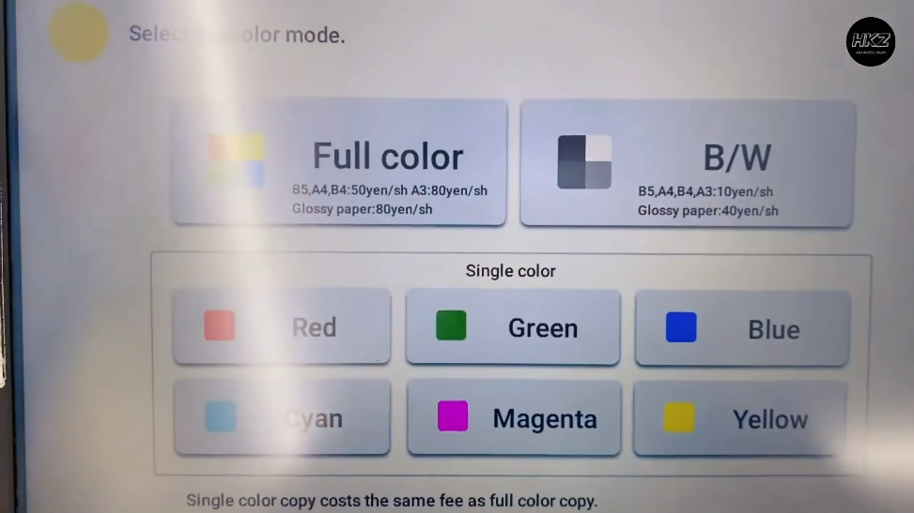

* Select Driving license

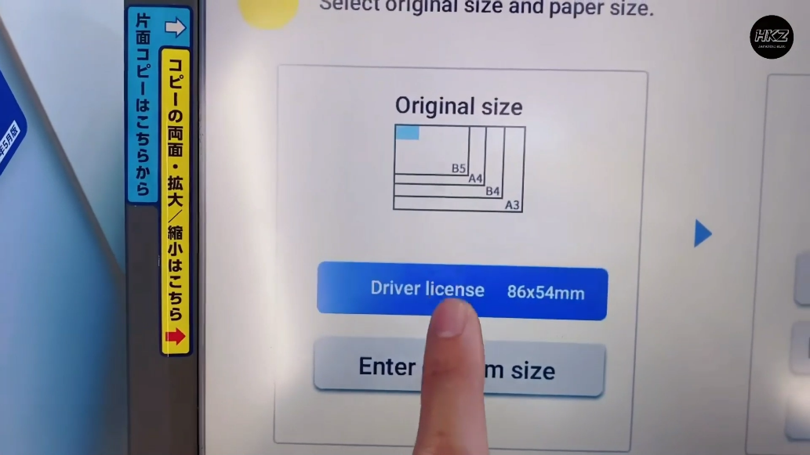

* Select paper size and click next

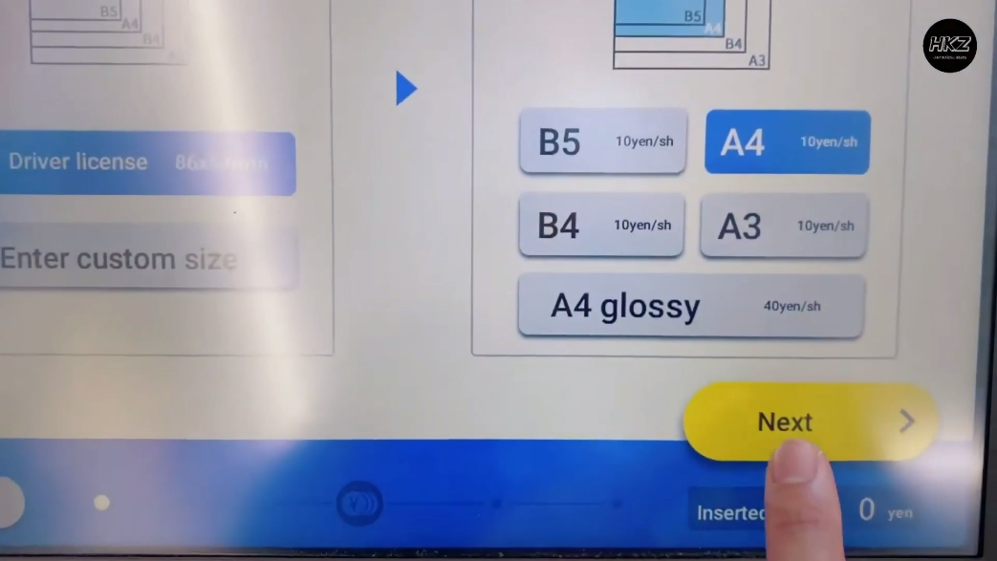

* Click Same size as original

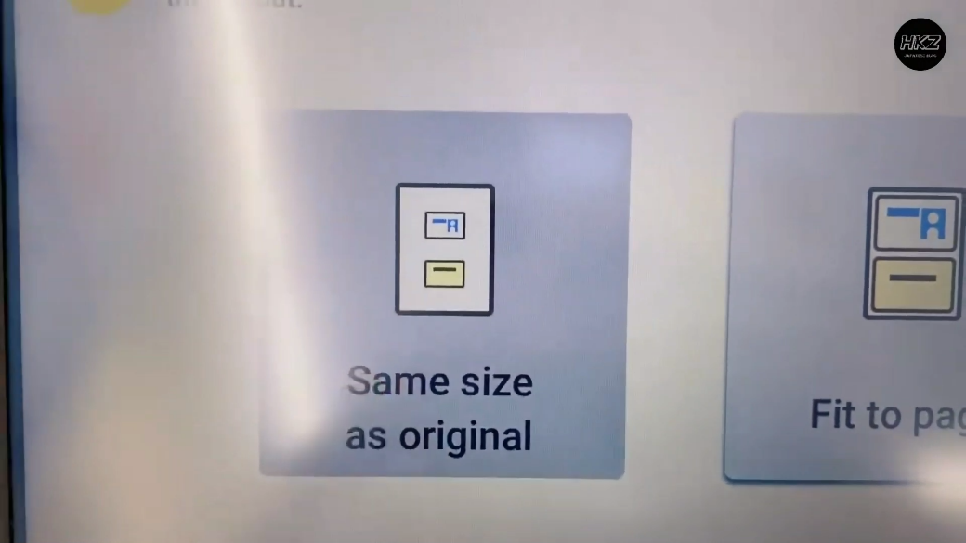

* Then keep front side of the Residence Card in the photocopy machine, close the lid and click the scan original

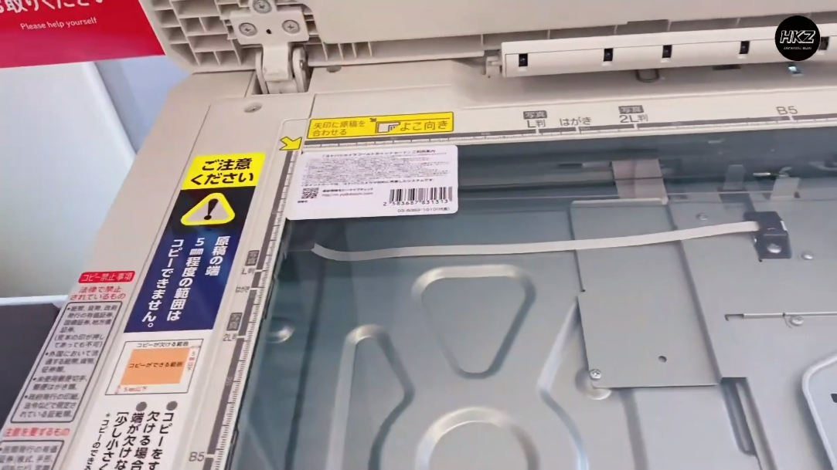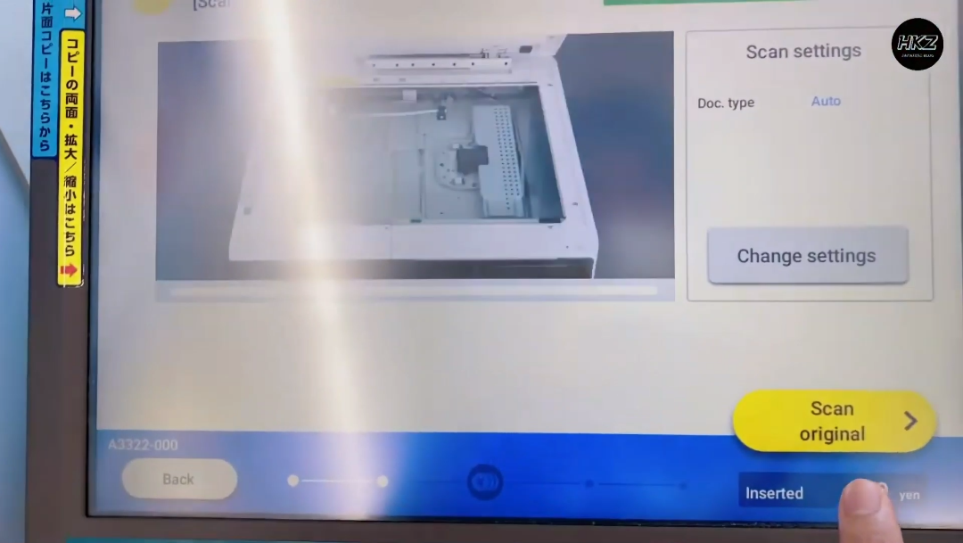

* Then keep the back side of the Residence Card in the photocopy machine, close the lid and click the scan original and then click Next.

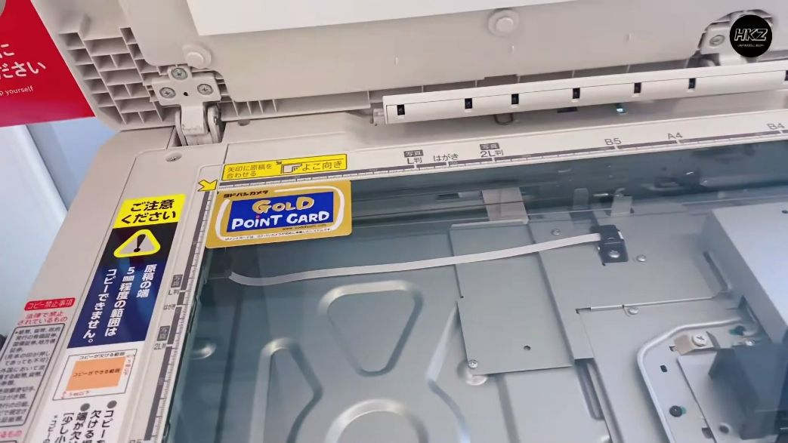



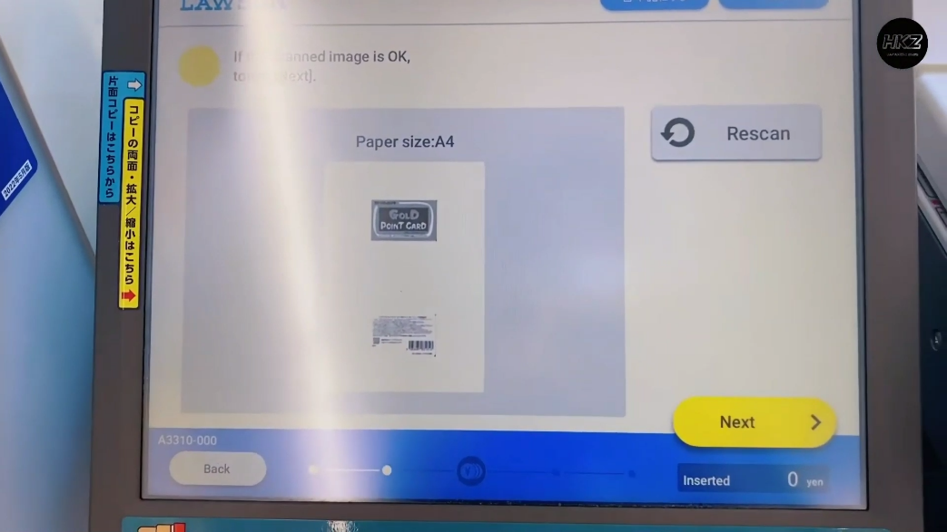

* Insert the coins and click start.

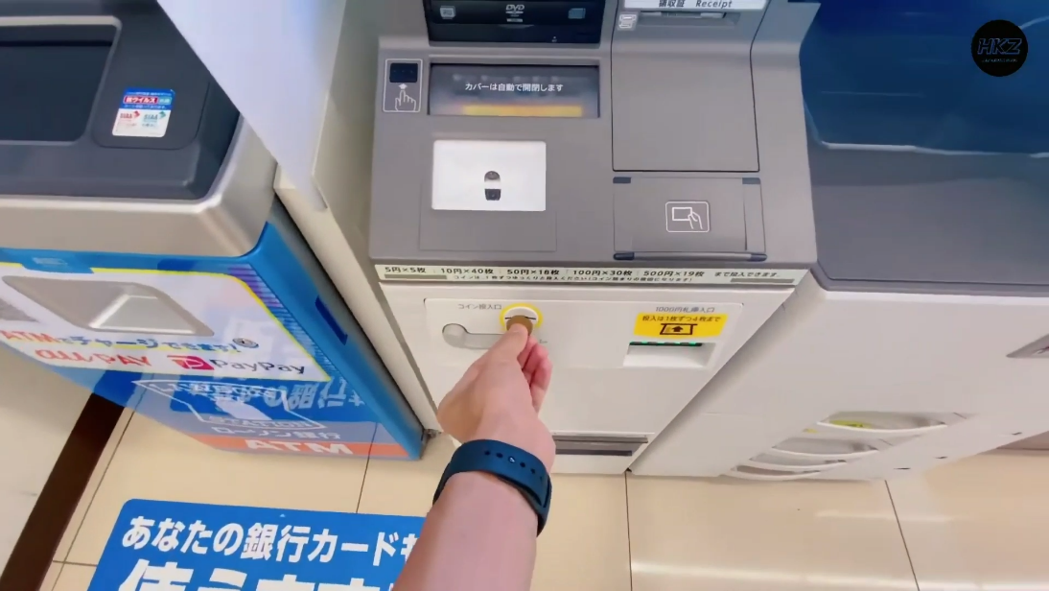

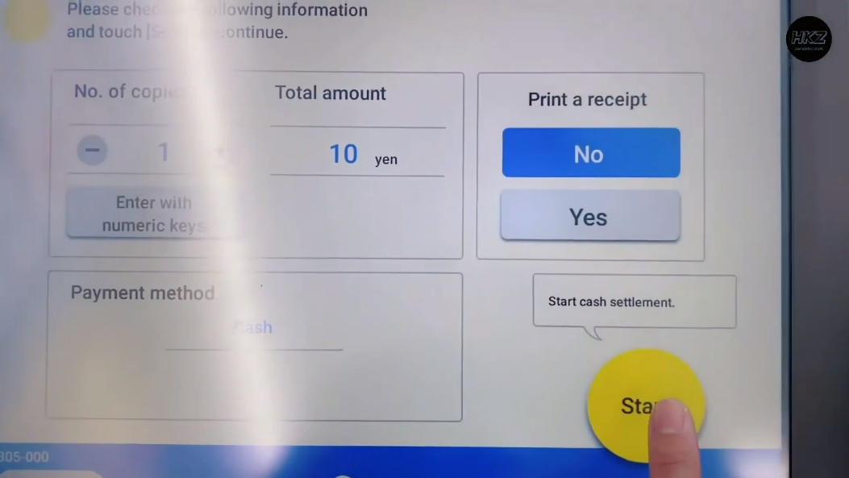

Finally, your scan document will be printed.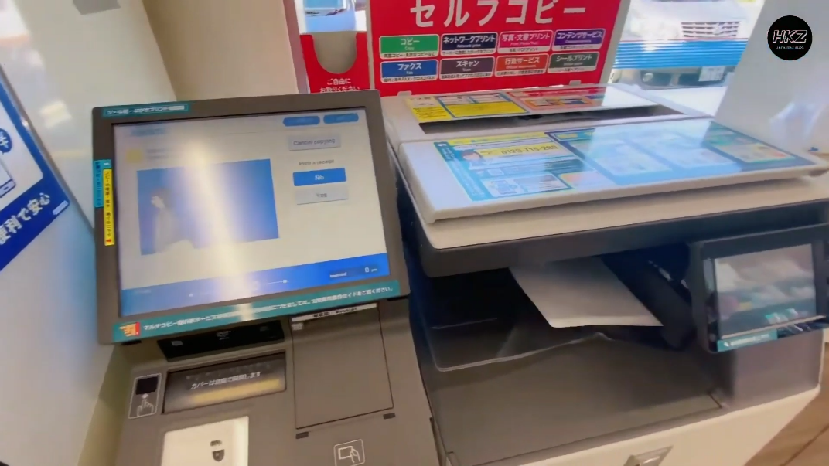

1. **Student Support Services**
   1. **Career Center**

Career Center will be support you for

* Job Information
* Interview Practice
* Resume check

Supporting Staff of the career center

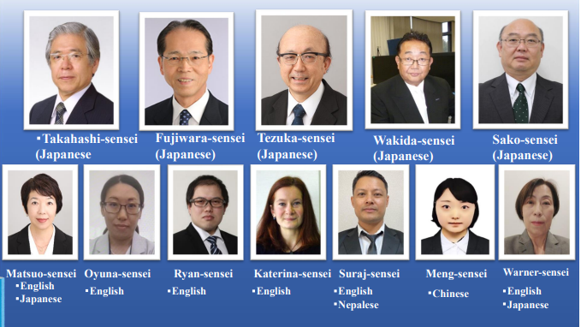

**Contact Details**

Email: kcgi_career@kcg.ac.jp

Telephone: 075-205-5148

Located in: Hyakumanben South Campus

Open Hours: weekdays 9:00-17:00

* 1. **English Writing Center**

What is for English writing center?

* Receive guidance on the contents of your English reports before submitting them.
* Improve your English writing skills.
* Review your resume.
  1. **Job hunting**

The university will be supported for job hunting activities.

* Conducting guidance sessions.
* Participate in off-campus guidance sessions.
* Practice for interviews.
* Connecting with internship opportunities.

1. **General Information**
   1. **Bicycle rule in Kyoto**

You can find more information about the “**Rules and Penalties on Riding Bicycle”**  from following websites.

<https://www.tsunagujapan.com/how-to-stay-safe-and-enjoy-riding-a-bicycle-in-kyoto/>

<https://www.pref.kyoto.jp/fukei/foreign/koki_k_t/jitensha/index.html>

* Bicycles must be ridden on the road, not on the sidewalk.

Children under the age of 13, elderly people over 70 years of age, or physically disabled people can use the sidewalk. The sidewalk may also be used if the road cannot be safely passed through (e.g. road construction).

* Bicycles keep to the left.
* Do not ride with an umbrella.
* Do not use earphones or headphones when you are riding.
* Do not ride using mobile phones or smartphones.
* Do not ride after drinking.
* Do not ride side-by-side.
* Do not carry a second person.
* Pay attention to stop signs.
* Use a headlamp at night.
* Do not cause obstructions with bicycle parking!

Obstructive bicycles will be removed immediately.

* 1. **Initial Procedures in Kyoto (Information source: -** [**https://www.studykyoto.jp/**](https://www.studykyoto.jp/) **)**
     1. **Register your place of residence.**

Foreigners who will stay in Japan for a period of more than three months will be issued a Residence Card when passing through immigration. You will also be required to register your place of residence at the local government office of the municipality in which you reside within 14 days of settlement in your residence. You will need to bring your Residence Card with you when registering your place of residence.

* + 1. **Enrollment in national health insurance.**

Foreigners who will stay in Japan for a period of more than three months must enroll in National Health Insurance. It is important that you enroll, otherwise you may be faced with expensive medical fees if you go to a hospital or clinic to treat illness or injury. You will be given a health insurance card once you subscribe.

* + 1. **Opening a bank account**

Open a bank account at an ordinary bank or a Japan Post Bank near your school or home.

Items required to open a bank account:

* Residence Card
* Health insurance card
* Student ID card (students only)
* Your seal (although some banks will allow you open an account with a signature)
* Money to deposit (you must open the account with at least 1 yen)
  + 1. **Subscribing to a mobile phone carrier**

You can purchase a mobile phone and subscribe to a mobile phone carrier at the outlet stores and distributors of each mobile phone carrier or at consumer electronics retailers such as Bic Camera and Yodobashi Camera.

Items required to subscribe to a mobile phone carrier:

* Residence Card
* Passport
* Japanese bank account (bank card / passbook). (If electing to have charges deducted from your bank account)
* National Health Insurance card. (If electing to have charges deducted from your bank account)
  1. **Transportation in Kyoto** **(Information source: -** [**https://www.studykyoto.jp/**](https://www.studykyoto.jp/) **)**
     1. **Trains**

There are 8 types of trains.

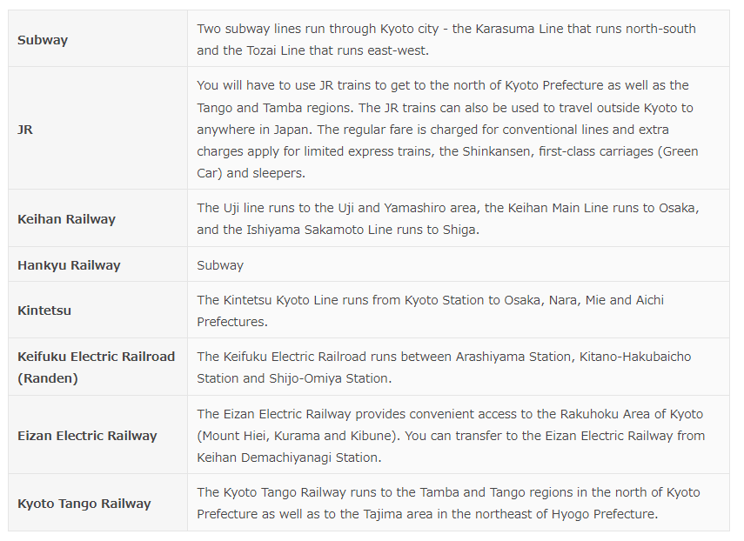

*Source: -* [*https://www.studykyoto.jp/en/currentstudents/kyotolife/traffic/*](https://www.studykyoto.jp/en/currentstudents/kyotolife/traffic/)

Purchase a ticket from the ticket vending machine before boarding the train. The fare to each destination will be displayed in a table, so please confirm the fare and purchase the correct ticket.

<https://guidetokyoto.com/fare-pass/train-fares/connection-ticket-jr-keihan/>

In addition to tickets, there are pre-charge IC cards such as ICOCA which requires 500 yen with no issue fee and IC cards such as PITAPA which does not require pre-charge.

<https://www.pitapa.com/merit/>

<https://www.jr-odekake.net/icoca/guide/>

* + 1. **Buses**

There are multiple bus services operating in Kyoto including Kyoto City Buses operated by Kyoto City and the privately-operated.

* Kyoto Kotsu
* Keihan Kyoto Kotsu
* Kyoto Bus
* Kyoto Keihan Bus
* JR Bus

Kyoto City Bus fare is flat rate ¥230 no matter where you get off (Some routes and sections change the price depending on the distances) The fare for privately-operated buses is calculated according to distance, so be sure to check the fare table at the front of the bus.

* 1. **How to dispose garbage**

Fill the designated household garbage collection bags up to a weight that can be carried in one hand, and tie the bags firmly. Be aware that if you put out your garbage in bags other than the designated bags they may not be collected. Designated bags are available at retail stores, supermarkets and convenience stores.

For more information

<https://www.studykyoto.jp/en/currentstudents/kyotolife/trash/>